Another Polarizing Vacuous Bad Actor

“Polarization and objectivity don’t mix well; the search for truth becomes submerged by the implicit and demanding question: Are you with us or ag’in us?” Garret Hardin [Hardin]

Let’s assume my premise is correct that people would accept facts if they knew what the facts were. A problem is that humans have collectively accumulated too many facts for any one person to comprehend. It is difficult for anybody to become an expert in any one subject let alone even a few. And it is impossible for a person to become knowledgeable about everything. It is also much easier for “bad actors” to make stuff up than it is for “good actors” to tell the truth because truth take effort. Ultimately, we have to rely on experts.

The conservative and polarizing pundit Tucker Carlson recently opined that we should not trust experts [Carlson]. This is irrational as his TV show is entirely dependent on experts whom he trusts explicitly. These experts include camera crews, sound engineers, graphic artists, lighting experts, stage and communications equipment managers, wardrobe and cosmetic specialists. All of the technology these people are using and Carlson is taking advantage of has been designed and developed by millions of scientists, engineers, and technicians, all experts at their particular disciplines. The building he is broadcasting from was designed by architects and engineers and built by myriad crafts people with various expertise from plumbing to ductwork. Plus, he is alive because expert farmers grew his food and experienced truckers and others in the transportation industry delivered it to him, not to mention all the many doctors, nurses and other health care specialists, whose services he has needed from time to time. His existence is a consequence of millions of experts whom he has trusted explicitly. According to Carlson, “experts” forecast that 150% of Americans would die without a lockdown. For the record, the experts he criticizes, epidemiologists, virologists, health care professionals, got the COVID19 forecast correct (see for example [Piot]) and nobody predicted 150% of Americans would die with or without a lockdown. Had President Trump listened to the experts, the country would have been much better prepared, fewer people would have died and the economic consequences would have been far less [Note].

Carlson, an ideological and therefore polarizing media pundit, is “merely eloquent” [Hardin] and not an investigative journalist. Those who are short on evidence but long on opinion, are forced to make the case that evidence doesn’t matter, which is what the tobacco lobby and the fossil fuels industry lobby have been doing for years [Orestes].

There is an important element of truth in Carlson’s little soliloquy. Wealth and power inequality in America are extreme and destroying the fabric of our society. This is shown in Figure 1. Conservatives in the Rust Belt have personal experience with their jobs being shipped overseas by large multinational corporations and billionaire elites. And many are angry, and rightly so, that President Obama bailed out the Wall Street bankers following the 2008 credit crisis. The total net worth of the nation’s 651 billionaires rose from $2.95 trillion on March 18, the start of the pandemic shutdowns, to $4.01 trillion on Dec. 7, a leap of 36%, [Collins]. Since the economy contracted, all this wealth came from the poor and the middle classes. In a new RAND study, Carter C. Price, Kathryn A. Edwards [Price] show that this is not a new thing, the wealthiest 1% have extracted over $50 Trillion from the economy at the expense of the working class and the middle class since 1975 [Hanauer].

While acknowledging wealth inequality, Carlson ignores the power inequality and attributes it to “government” and “socialism”. However, this is an ideologically drawn conclusion and not a reflection on data or evidence. His examples of egregious wealth accumulation are “liberals” such as Jeff Bezos. A liberal pundit would express exactly the same sentiment but attribute it to “greed” and conservatives like “Rupert Murdoc”. Carlson decries this inequality because it leads to envy; in other words, the problem experienced by the destitute is not that they are homeless and living in their cars or in cardboard boxes under bridges and have no health care and don’t get enough to eat and cannot find jobs but that they are jealous. Inequality keeps getting worse despite whatever good or bad intentions the wealthy might possess until it is redistributed by revolution, war or natural disaster [Scheidel]. Carlson’s solution is free market capitalism, which is of course, not a solution because markets have always led to inequality and in fact, “free markets” are not even possible.

Adam Smith observed that there is a positive feedback loop between wealth and power which has existed before Hammurabi. Yet this important economic law is absent in economic text books, including Mankiw’s [Mankiw]. And it is why no system of government or economy has ever worked for the benefit of humanity in general and for future generations and biosphere health. And it is why democracies are rare in human history and hard to maintain when they do appear. Ignoring this law is why economists failed to forecast the 2008 credit crisis and never bothered to think through the possibility of a pandemic and its impact on the economy despite epidemiologist’s reasonably accurate forecasts [Piot]. Economists, once again failed to do their jobs.

Carlson’s cluelessness is also due to the Dunning-Kruger Effect. He says: “if you start to get the impression that dishonest people can easily manipulate data to tell you any story, they want to tell you, you may be on to something.” He is right and he is one of these dishonest people. For proof that it is Democrats and socialism which causes the inequality, he points out that Representative Ilhan Omar’s husband, Tim Mynett, received Paycheck Protection Program (PPP) loans and Economic Injury Disaster loans [Betz]. Carlson also singles out Georgia Senate candidate Pastor Raphael Warnock because a non-profit he formerly headed accepted a PPP loan.

Carlson ignores that Republican Representatives. Roger Williams of Texas, who owns auto dealerships and car repair shops, Vicky Hartzler of Missouri, whose family reportedly owns farms and equipment suppliers in the Midwest, and Democratic Representatives Susie Lee of Nevada whose husband is associated with a casino developer, Debbie Mucarsel Powell from Florida, whose husband is a senior executive at a restaurant chain have all received PPP loans [Singman]. Carlson does not mention that Pastor Joel Osteen’s Lakewood Church received $4.4M COVID-19 PPP loan [Eustachewich]. For the record, Warnock’s net worth is about $1.6 million and Osteen’s net worth exceeds $100 million [wealthrecord]. Warnock’s opponent in the Georgia Senate race, Kelly Loeffler is worth over $800 million and is currently being investigated for ethics violations [Fung]. Carlson ignores the fact that the Trump administration has tried to block information about PPP loans from being made public [Popken] and that businesses associated with Trump and his son-in-law Jared Kushner received $3.65 million in PPP loans [Zoellner]. Carlson’s selectivity is intended to polarize.

My point is not to criticize any of these people for taking PPP loans. In fact, the four representatives told Politico the loans were acquired properly and part of their efforts to keep their workers employed [Singman]. I’m critical of Carlson’s cherry-picking. The PPP loans amounted to $438 million as compared to the over $1 billion in real wealth which the market economy transferred from the poor and the middle class to the billionaire class [Collins] during the COVID lockdowns and over $50 trillion because of conservative economic policies on the part of both political parties. The problem with this massive wealth and power transfer is not that it is making people jealous but that it is making people poor.

Carlson uses polarizing language to refer to Representative Alexandria Ocasio-Cortez as a “vacuous idiot, another rich girl narcissist with an overheated twitter account.” Ocasio-Cortez has a net worth of $7,000 [Rivero] compared to Carlson’s net worth of $40 million [networthbro]. As a high schooler she placed second in the microbiology category of the Intel International Science and Engineering Fair in 2007 with a research project on the effect of antioxidants on the lifespan of the nematode Caenorhabditis elegans. In a show of appreciation for her research, the MIT Lincoln Laboratory named a small asteroid after her: 23238 Ocasio-Cortez [Wiki]. Carlson’s description is a much better match for Carlson himself, and it perfectly describes twitter stormer Donald Trump. According the Carlson, we should be worried that Ocasio-Cortez might run for president someday. I hope so.

If Carlson wants to inform the public about corruption here is a place to start [Rupar]:

“Donald Trump is the first president in modern history to refuse to divest from his business interests upon taking office. As a result, he reportedly took in at least $73 million from foreign sources during his first two years in office, creating an unprecedented tangle of conflicts of interest with countries like the Philippines, India, and Turkey that are home to Trump-branded buildings.”

And this from Ananya Chakravarti, associate professor in the Department of History at Georgetown University [Chakravarti]:

“The strong-arm leaders Trump assiduously cultivates, from India’s Modi to the Philippines’s Rodrigo Duterte and Turkey’s Recep Tayyip Erdogan, all head countries that house his most lucrative overseas businesses—and they know it. Not only do these countries extract more in tax revenue from Trump than the United States itself, but their leaders have cannily used his business entanglements to diplomatic advantage. Duterte chose the businessman behind the Trump Tower in Manila as his envoy, while Erdogan’s delegations and Turkish state businesses patronize Trump establishments in the United States selectively as a reward for U.S. diplomatic compromise with Turkey. …

…Trump’s career is ultimately a product of this interconnected and profoundly corrupt world, in which celebrity, wealth, and power are interchangeable currency and which makes a mockery of the rule of law and of democracy.”

Carlson is a polarizing neo-liberal free market ideologue. His ideology, like all ideologies blinds him to evidence which contradicts the ideology. He is merely eloquent; high on rhetoric, low on substance. This is why he cherry-picks his data when he uses data and otherwise lies. But it is also why, when looking for facts, we should ignore him.

This interview with Christine Todd Whitman is a reminder, if we acknowledge the facts and science and heed expert advice, we can all get along and together address our problems [Whitman].

[Note] The reason our country suffered more from the coronavirus than other countries is because Trump lied [Woodward] and because he refused to take his responsibility as president seriously [Sebenius]. He didn’t care. A president is also responsible for uniting the entire country during times of crises, as President George W. Bush did after the terrorist attacks on September 11, 2001 and as President Obama did after Hurricane Sandy, just by example. Trump’s “I’m not responsible” is a far cry from President Truman’s “the buck stops here”. Trump, instead, used it as an opportunity to polarize and divide the country. Trump doesn’t care.

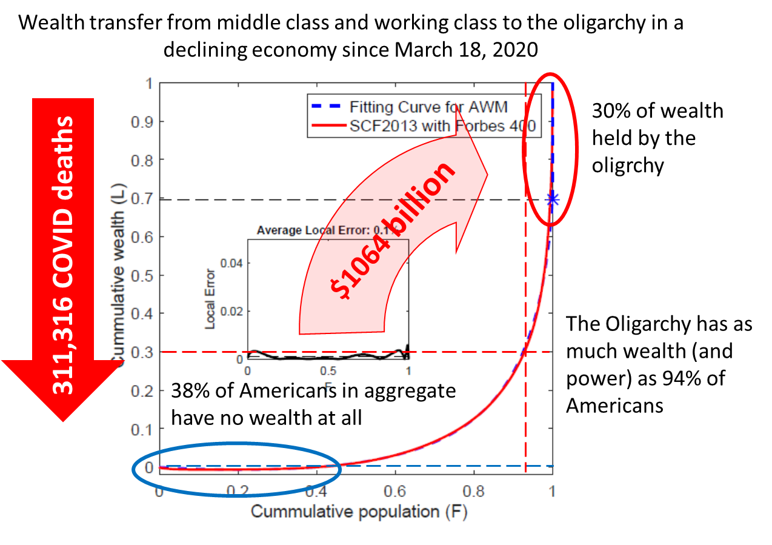
Figure 1. wealth transfer between March 18 and December 7, 2020 [Collins]. COVID deaths in America up to December 15, 2020 [worldometers].

[Betz] Bradford Betz, https://www.foxnews.com/politics/firm-co-owned-by-ilhan-omars-husband-received-500k-in-covid-bailout-on-top-of-millions-from-her-campaign

[Carlson] Tucker Carlson, “Experts have been exposed as frauds”, https://www.youtube.com/watch?v=63WeY7FRfQ0

[Chakravarti] Ananya Chakravarti, associate professor in the Department of History at Georgetown University, Trumpworld’s Corruption Is as Globalized as the Ultra-Rich the President Mingles With, October 12, 2020,

[Collins] Chuck Collins, Inequality, December 9, 2020, Updates: Billionaire Wealth, U.S. Job Losses and Pandemic Profiteers - Inequality.org

[Eustachewich] Lia Eustachewich, https://www.foxbusiness.com/lifestyle/joel-osteen-lakewood-church-coronavirus-ppp-loan

[Fung] Katherine Fung, 11/19/2020, Kelly Loeffler Net Worth: All the Controversies Surrounding America's Richest Senator, https://www.msn.com/en-us/news/politics/kelly-loeffler-net-worth-all-the-controversies-surrounding-americas-richest-senator/ar-BB1bbdnv

[Hanauer] Nick Hanauer and David M. Rolf, September 14, 2020, The Top 1% of Americans Have Taken $50 Trillion From the Bottom 90%—And That's Made the U.S. Less Secure, https://time.com/5888024/50-trillion-income-inequality-america/

[Hardin] Garrett Hardin, Filters Against Folly: How To Survive Despite Economists, Ecologists, and the Merely Eloquent, 1986

[networthbro] https://networthbro.com/tucker-carlson-net-worth/

[Oreskes] Naomi Oreskes and Erik M. Conway, Merchants of Doubt: How a Handful of Scientists Obscured the Truth on Issues from Tobacco Smoke to Global Warming, Bloomsbury Press, 2010

[Piot] Peter Piot, October 24, 2018, Royal Institute Lecture, https://www.youtube.com/watch?v=en06PYwvpbI

[Popken] Ben Popken and Andrew W. Lehren, November 6, 2020, Judge orders Trump administration to reveal PPP loan data it sought to obscure. NBCNews.

[Price] Carter C. Price, Kathryn A. Edwards, Trends in Income From 1975 to 2018, RAND White Paper, August 14, 2020, https://www.rand.org/pubs/working_papers/WRA516-1.html

[Rivero] Kamila Rivero, https://www.cheatsheet.com/entertainment/what-is-alexandria-ocasio-cortezs-net-worth-and-how-much-is-her-salary.html/

[Rupar] Aaron Rupar, Oct 21, 2020, The stunning hypocrisy of the Trump family’s attacks on Hunter Biden, If there’s any family that should sit out attacking others for alleged corruption, it’s the Trumps. https://www.vox.com/2020/10/21/21525326/trump-family-hunter-biden-corruption-explained

[Scheidel] Walter Scheidel, The Great Leveler; violence and the history of inequality from the stone age to the twenty-first century, 2017.

[Sebenius] https://www.statnews.com/2020/06/19/faster-response-prevented-most-us-covid-19-deaths/

[Singman] Brook Singman, Fox News, https://www.foxnews.com/politics/several-house-lawmakers-benefit-from-coronavirus-ppp-loans-report

[wealthrecord] https://www.thewealthrecord.com/celebs-bio-wiki-salary-earnings-2019-2020-2021-2022-2023-2024-2025/pastor/joel-osteen-net-worth/

[Wiki] https://en.wikipedia.org/wiki/Alexandria_Ocasio-Cortez

[Whitman] https://www.youtube.com/watch?v=AGkIn4SGT_I

[worldometers] https://www.worldometers.info/coronavirus/country/us/

[Zoellner] Danielle Zoellner, https://www.independent.co.uk/news/world/americas/us-politics/donald-trump-jared-kushner-ppp-loan-coronavirus-b1765356.html

